Education Grade-level Outcomes:

Grades K-5 (Physical Activity Knowledge)
Standard 3 [E1.K,2,3a,5] Identifies active play opportunities outside physical education class (K); Describes physical activities for participation outside physical education class (e.g., before and after school, at home, at the park, with friends, with the family) (2); Charts participation in physical activities outside physical education class (3a); Charts and analyzes physical activity outside physical education class for fitness benefits of activities (5).

BEAN BAG
Activity Name | Description | Outcome Focus
PART 1
Locomotor Moves | With bean bag on the floor in personal space:  - Walk around the activity area and count all of the bean bags.  - Jog in the area. On signal, freeze and point to any beanbag.  - Gallop in the area. Freeze, listen for a color, and then find a beanbag that color and touch it with your toe.  - Leap over beanbags in area.  - Slide (jump, hop, skip) in the area. When music stops, find a new bean bag and stand on it. | Travels in Relationship with Objects
Toss and Try | Toss bean bag straight up and then:  - Clap 1 time before it hits the floor.  - Clap 1 time and then try to catch it.  - Clap as many times as you can before it hits the floor.  - Clap as many times as you can and then try to catch it.  - Toss with right hand only (repeat tasks above)  - Toss with left hand only (repeat tasks above)  - Toss and turn 360 degrees before the bean bag hits the floor.  - Start with the beanbag on top of your foot. Flip it into the air and try to catch it. | Catches a Soft Object
Super Moves | With bean bag on the floor:  •  Stretch your body  and log roll over it back and forth.  •  Start low like a frog, and then j  ump over it backward and  forward; side  -  to  -  side.  •  Sit on the floor.  Stretch and curl by picking the beanbag  up with  your feet, reach  ing  and touching it with your  hands, and then stretch  ing  and set  ting  it back down. | Demonstrates Twisting, Bending, Stretching
PART 2
Balancing Act | With bean bag balancing on head, shoulders, or back:  - Balance on one foot. Shift to balance on the other foot.  - Sit and then stand again. If the beanbag falls, try again.  - In plank position, slowly slide your feet around in a circle. | Weight Transfer and Balance/Stability
Slow and Fast | - Use your foot to slowly slide the bean bag around the activity area.  - Slide the bean bag on the ground, back and forth from hand to hand. How fast can you make the bean bag slide while keeping it under control? | Differentiates between fast and slow speeds and strong and light force.
Target Practice | Each student finds a spot on the wall as a target (e.g., a brick, piece of paper, etc.) Toss the bean bag underhand to:  - Hit the center of the target.  - Hit the edges of the target.  - Hit just above (below, to the sides) of the target. | Throws Underhand Using a Mature Pattern
Partner Fun | Using 1 beanbag per pair:  - Toss and catch the bean bag.  - Slide it back and forth on the ground.  - Pass it back and forth like a soccer ball, using your feet.  - Try all of the above using 2 bean bags | Working With Others

Yoga Pose Cards
Print, Cut, Laminate
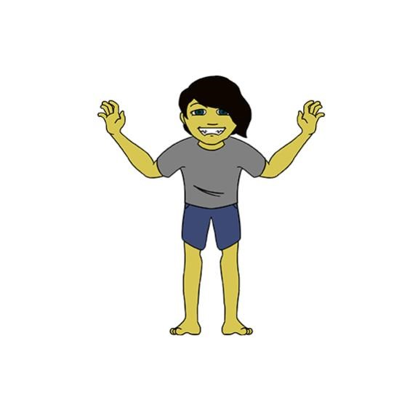  Beginning | 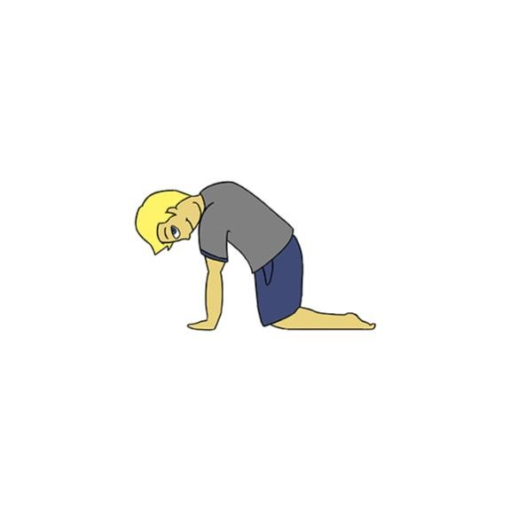  Cat
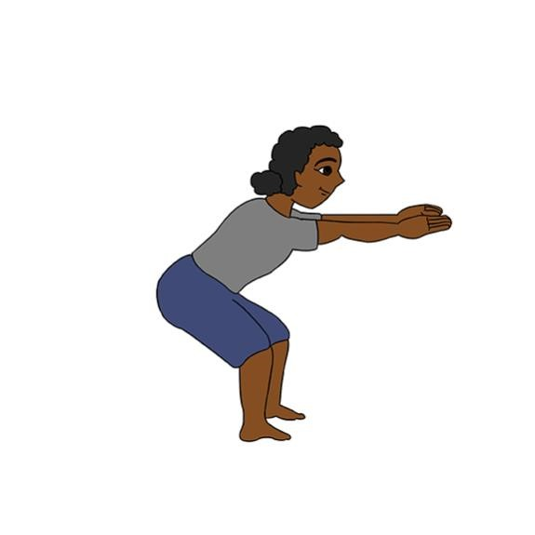  Chair | 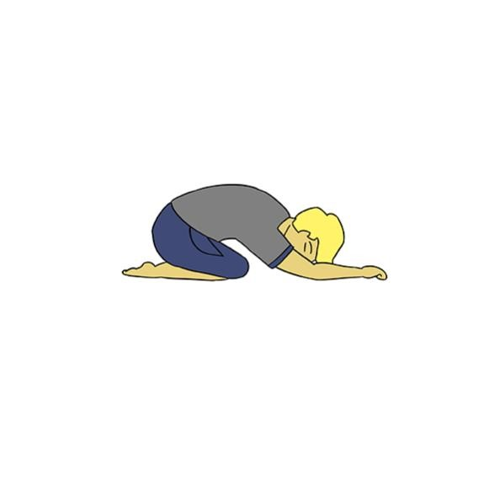  Child

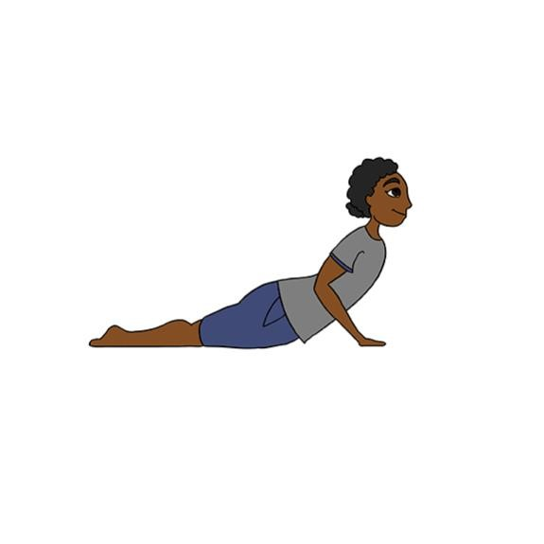  Cobra | 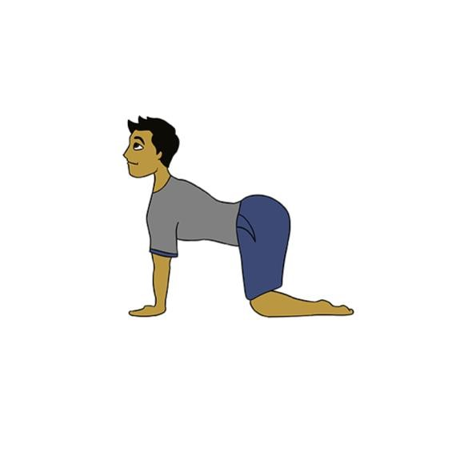  Cow
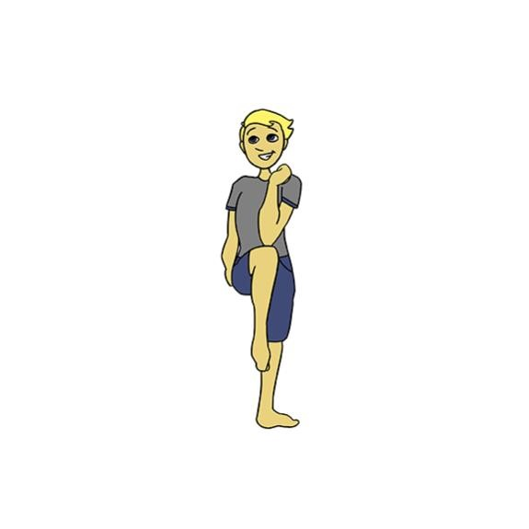  Cross-Crawl 1 | 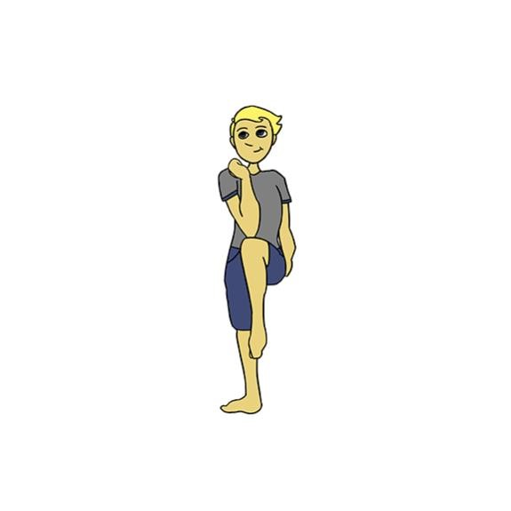  Cross-Crawl 2

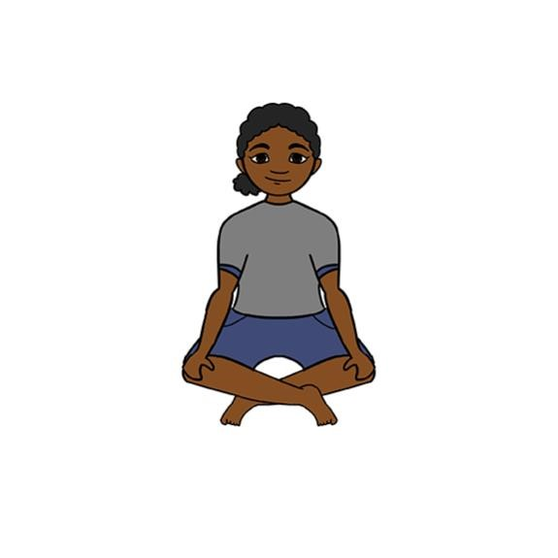  Cross-Legged | 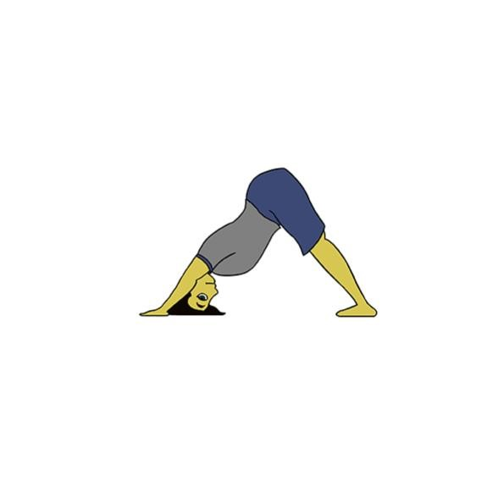  Down Dog
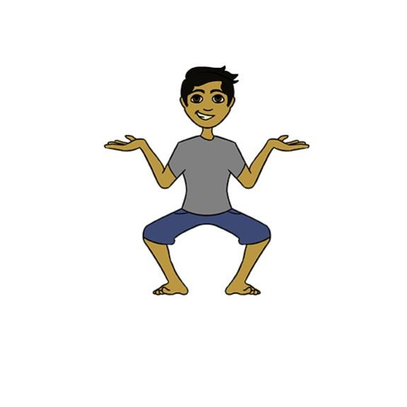  Goddess | 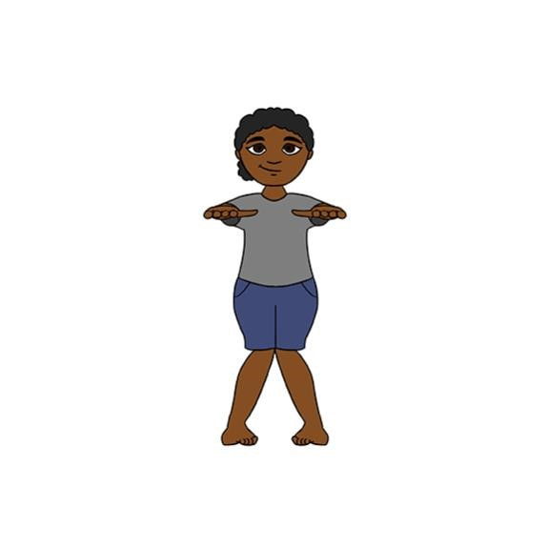  Knobby-Knees

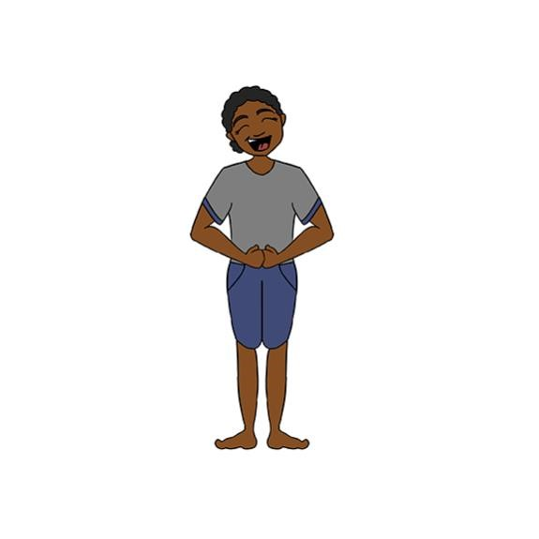  Laugh | 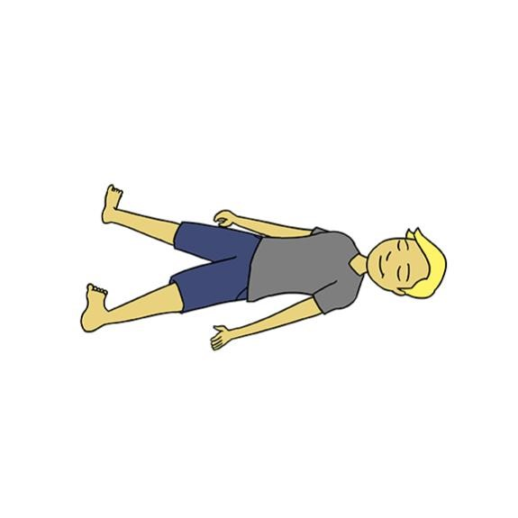  Limp Noodle
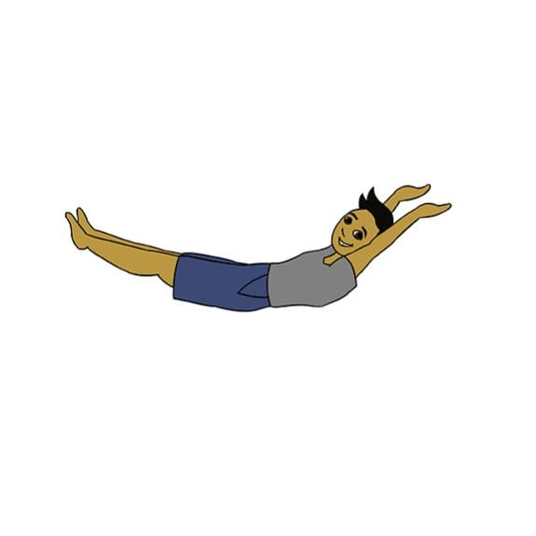  Log 1 | 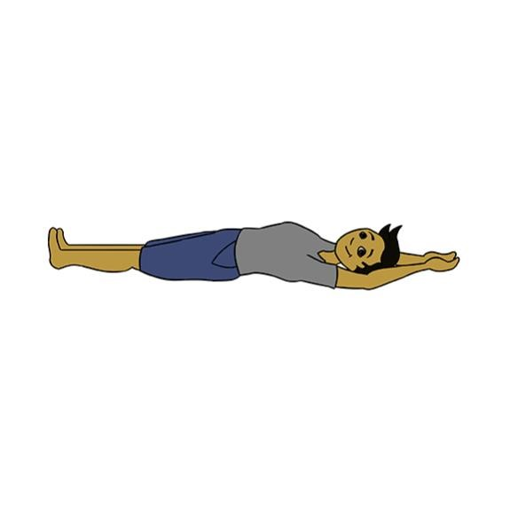  Log 2

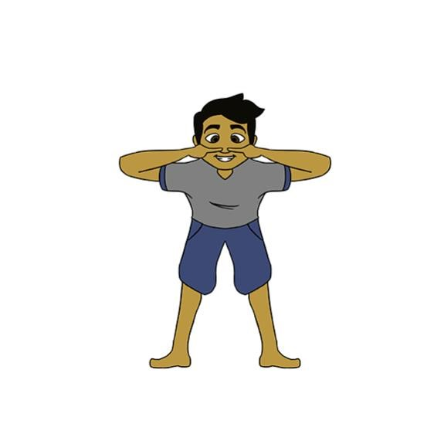  Nose | 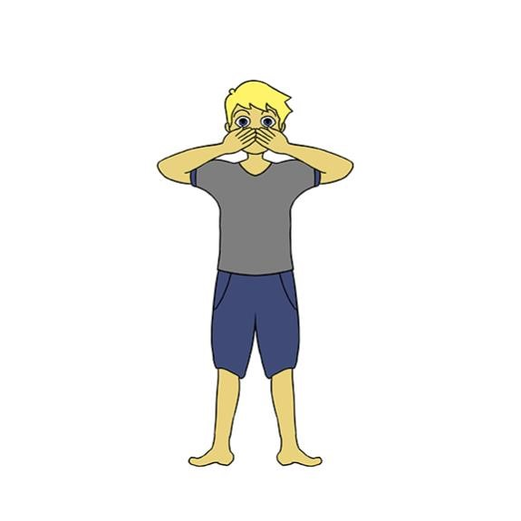  Oh No!
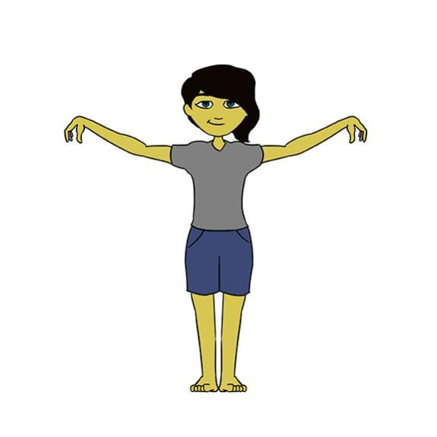  Owl 1 | 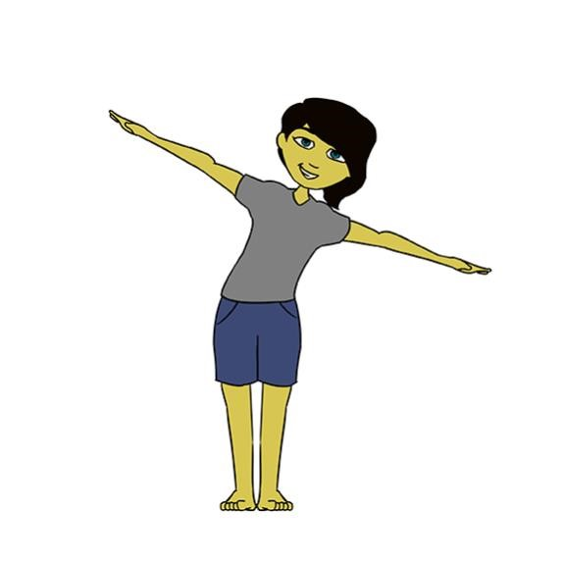  Owl 2

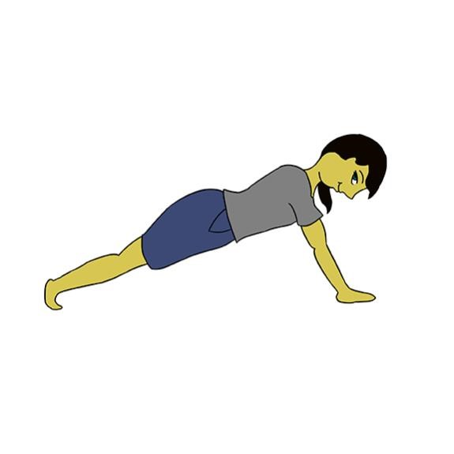  Plank | 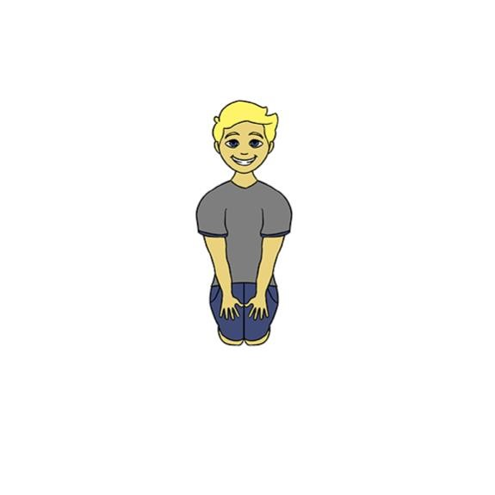  Rock
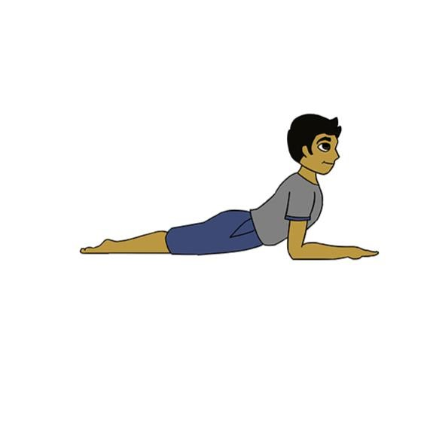  Sphinx | 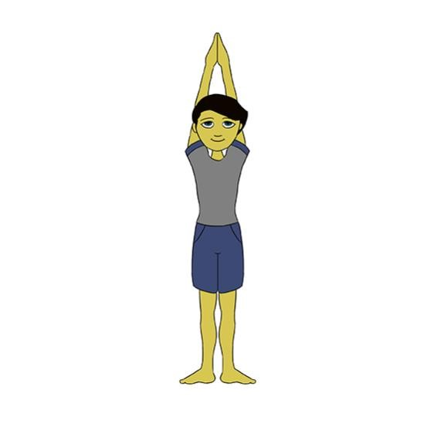  Tall Mountain

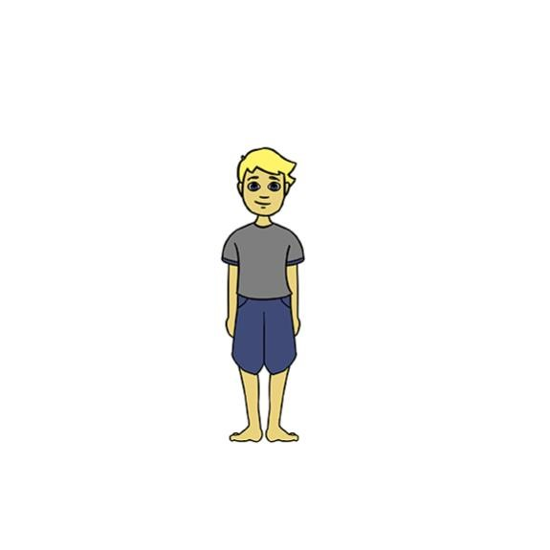  Tree 1 | 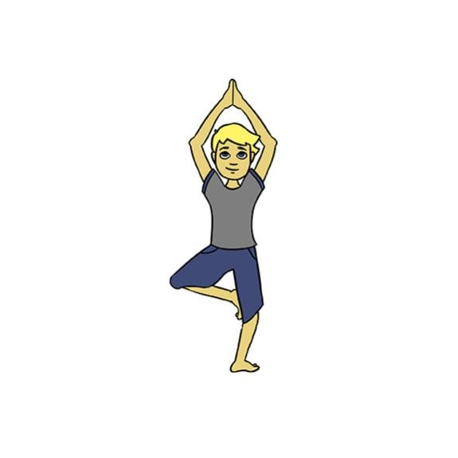  Tree 2
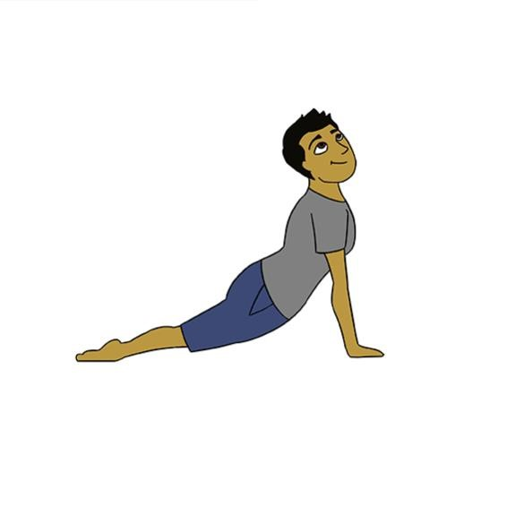  Up Dog | Down Dog

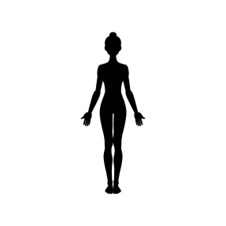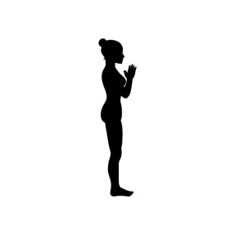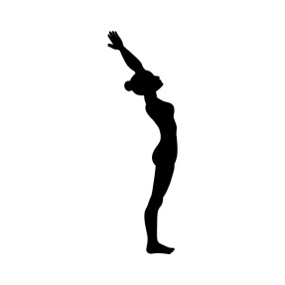

Peer Teaching Activity Card 1: Sun Salutations

Stand in mountain pose and inhale.

Exhale. Hands to heart center or prayer.

Inhale. Reach up and back, keeping the biceps in the line with
the ears and the palms facing
forward. Push the hips forward
and focus on extending the spine.

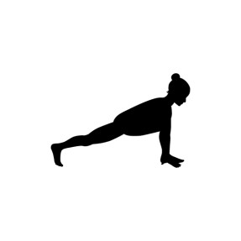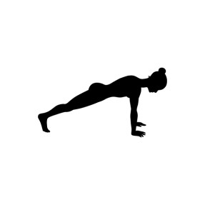

Peer Teaching Activity Card 2: Sun Salutations

Exhale. Fold forward and down. Keep the arms in line with the
biceps and the back flat. Line the finger tips up with the toe tips
and
bend the knees as much as you need in order to get your
hands flat on the floor.

Inhale. Step back with the right leg, drop the back knee, and look
up.

Retain the breath (hold) and step back to a plank position.

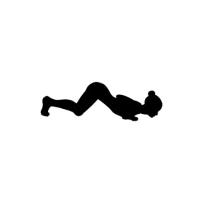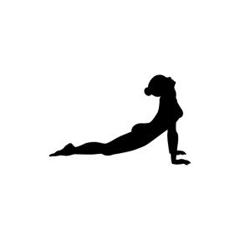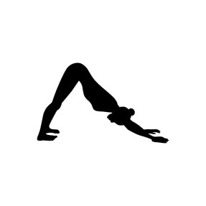

Peer Teaching Activity Card 3:

Sun Salutations

Exhale. Lower the chest down between the hands and the knees
to the floor. Place the chin on the mat. Keep the hips up (like an
inch worm).

Inhale. Slide forward into cobra pose, keeping the knees, hands,
and feet in the same spot.

Exhale. Lift the knees off the floor and shift the hips back into an
inverted “V,” or downward
-
facing dog pose.

Peer Teaching Activity Card 4: Sun Salutations

Inhale. Look between and the hands and step forward with the
right foot. Place the
foot between the hands, drop the back knee,
and look up.

Exhale. Step forward with the left foot and bring the head to the
knees.

Inhale. Reach the arms out with the hands palms
-
down, and
begin to stretch up and back. Keep the biceps in line with
ears.
Lift the chest and focus on thoracic extension.

Exhale. Drop the arms by the sides, returning to mountain pose.

